Creating the required files (HTML, nginx.conf, Dockerfile)

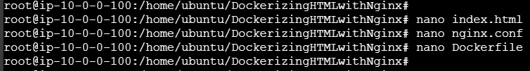

Building Image with tagging the Image (using -t)

D:\Batch8\Docker niginx with HTML\unnamed.png

Running the Image detached mode (using -d) and port mapping with port 80 (using -p)



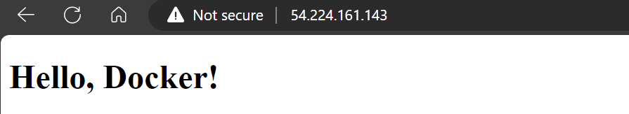

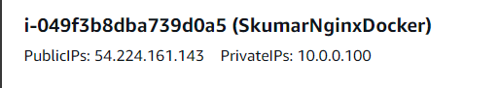

Login to the ECR running below command got from ECR repository.



Pushing the Built image to the ECR repository.

